

Table of Contents

1. Phase 1: Asteroid Exploratory & Predictions

1.1 Introduction

1.2 Libraries Used

1.3 Data Loading and Preprocessing

1.4 Exploratory Data Analysis (EDA)

- 1.4.1 Identifying Asteroids by Size

- 1.4.2 Identifying Asteroids by Velocity

- 1.4.3 Identifying Asteroids by Distance

- 1.4.4 Identifying Asteroids by Brightness

1.5 Class Balance Analysis

2. Phase 2: Asteroid Deflection Simulation using Satellite Impact

2.1 Purpose of the Program

2.2 Key Physical Concepts Used

- 2.2.1 Momentum Conservation (Impact Effect)

- 2.2.2 Forces Acting on the Asteroid

2.3 Program Breakdown

- 2.3.1 Defining Constants and Initial Conditions

- 2.3.2 Motion Equations (impact_effect function)

- 2.3.3 Solving the Motion (solve_ivp)

2.4 Visualization and Plots (advanced_plots function)

- 2.4.1 Main Trajectory Plot

- 2.4.2 Inset Plot (Zoomed Close Approach)

- 2.4.3 Speed vs. Time

- 2.4.4 Altitude vs. Time

- 2.4.5 Acceleration vs. Time

3. Phase 3: Sun Flares Detection System

3.1 Predicting Solar Flare Peak Current and Energy Magnitude Using Recurrent Neural Networks

3.2 Systematic Hyperparameter Tuning

- 3.2.1 Grid Search

- 3.2.2 Random Search

- 3.2.3 Bayesian Optimization

3.3 Modular and Transparent Implementation

3.4 Significance and Applications

3.5 Plots/Results

- 3.5.1 Plot 1: Time vs. Peak1

- 3.5.2 Plot 2: Time vs. Total Count

- 3.5.3 Plot 3: Energy Levels vs. Frequency

- 3.5.4 Plot 4: Time vs. EL

- 3.5.5 Plot 5: Count vs. Energy

4. Phase 4: Ionospheric Shield System for Solar Storm Mitigation

4.1 Introduction

4.2 Key Components of the Program

- 4.2.1 Space Weather Simulation

- 4.2.2 Plasma Heating Mechanic

- 4.2.3 Ionospheric Heater Network

4.3 Results/Plots

- 4.3.1 Plot 1: Time vs. Particular Deflection vs. Isotopes Temperature vs. Cumulative Energy

- 4.3.2 Plot 2: Impact Plot

- 4.3.3 Plot 3: Plasma Heat Evolution

4.4 Technologies Used

4.5 Goal

4.6 Contributions

5. Conclusion

5.1 Insights from Asteroid Analysis

5.2 Simulation of Asteroid Behavior

5.3 Applications and Extensions

phase 1

**Asteroid Exploratory & Predictions.**

1. Introduction

This section gives an overview of the program. The primary goal is to analyze an asteroid dataset using Exploratory Data Analysis (EDA). The dataset contains information about various asteroids, including their size, velocity, brightness, and proximity to Earth. Additionally, the analysis checks for class balance to determine if the dataset is suitable for machine learning models that predict hazardous asteroids.

2. Libraries Used

Several Python libraries are used in the program:

pandas: Handles dataset loading, filtering, and manipulation.

numpy: Used for mathematical and numerical operations.

matplotlib.pyplot & seaborn: Create plots and graphs for data visualization.

warnings: Suppresses unnecessary warnings for better readability.

scikit-learn: Provides tools for feature selection, scaling, and classification.

imblearn: Handles imbalanced datasets, useful for machine learning.

feature_engine: Detects and treats outliers in the dataset.

3. Data Loading and Preprocessing

The dataset is loaded from a CSV file.

The program checks for data types using dtypes to ensure correctness.

Missing values are identified using isnull().sum(), helping to determine if imputation is needed.

Duplicates are checked using duplicated().sum(), which ensures data integrity.

The describe() function provides summary statistics, including mean, minimum, maximum, and quartile values for numerical features.

4. Exploratory Data Analysis (EDA)

EDA helps uncover patterns, trends, and anomalies in the data.

a) Identifying Asteroids by Size

Largest Asteroids: The program identifies the top 5 asteroids with the largest estimated maximum diameter.

Smallest Asteroids: The program identifies the top 5 asteroids with the smallest estimated minimum diameter.

Visualization: Bar charts help in comparing asteroid sizes.

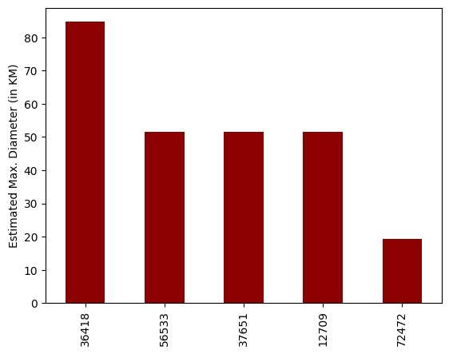

plot 1.1 Estimated max diameter. 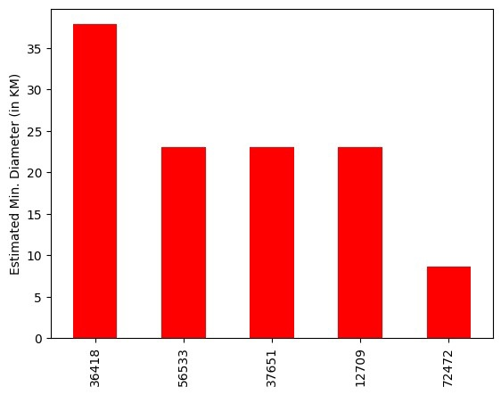

plot 1.2 Estimated min diameter.

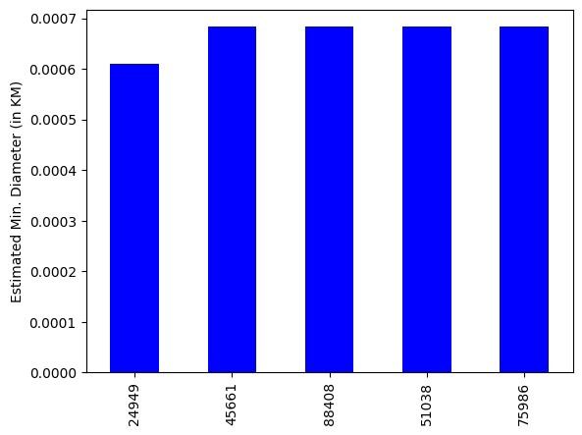

Plot 1.3 Estimated min

b) Identifying Asteroids by Velocity

Fastest Asteroids: Sorted by relative_velocity, showing the top 5 fastest-moving asteroids.

plot 2.1 Relative velocity to Earth.

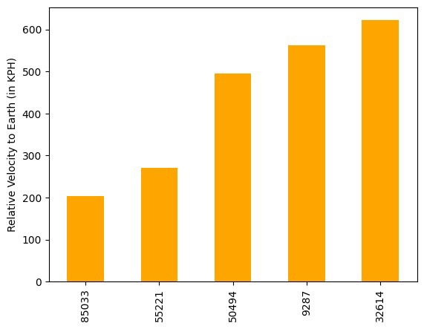

Plot 2.2 Relative velocity to Earth

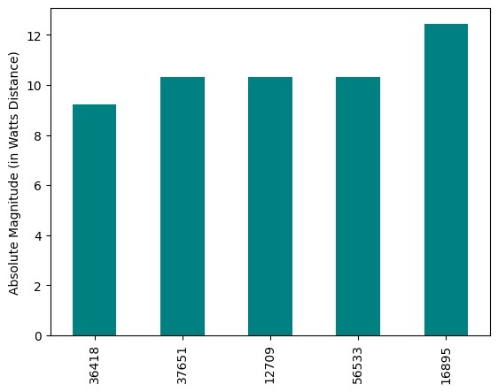

Plot 2.3 Absolute Magnitude in Watts distance

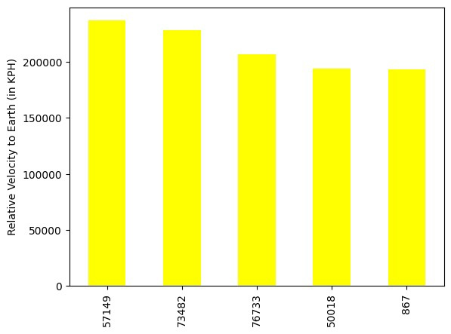

Plot 2.4 Relative velocity to Earth

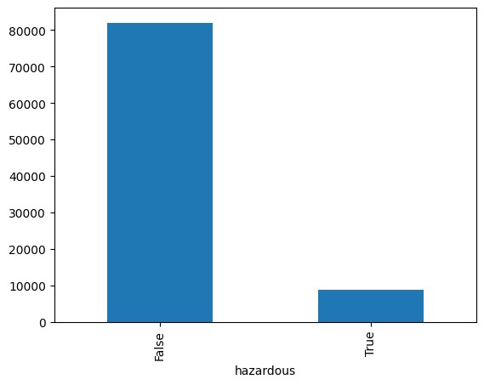

Plot 5 Hazardous predictions.

Slowest Asteroids: Identifies the top 5 slowest-moving asteroids.

Visualization: Bar charts help compare velocity differences.

c) Identifying Asteroids by Distance

Closest Asteroids: Asteroids that passed closest to Earth (smallest miss_distance).

Furthest Asteroids: Asteroids that passed farthest from Earth.

Visualization: Bar charts illustrate proximity to Earth.

d) Identifying Asteroids by Brightness

Brightest Asteroids: Asteroids with the highest absolute magnitude.

Dimmest Asteroids: Asteroids with the lowest absolute magnitude.

Visualization: Bar charts compare brightness levels.

5. Class Balance Analysis

The hazardous column is analyzed to check the distribution of hazardous vs. non-hazardous asteroids.

A bar chart is used to visualize the class balance.

This step is important for machine learning models, ensuring that hazardous asteroids are not underrepresented.

Phase 2

Asteroid Deflection Simulation using Satellite Impact.

1. Purpose of the Program

Simulates an asteroid impact event, where a satellite collides with an asteroid, changing its velocity.

Models the asteroid's trajectory around a planet, considering:

Gravitational pull of the planet.

Atmospheric drag (if the asteroid enters the atmosphere).

Solar radiation pressure (force from sunlight).

2. Key Physical Concepts Used

Momentum Conservation (Impact Effect)

When the satellite hits the asteroid, its velocity changes due to the conservation of momentum.

Forces Acting on the Asteroid

Gravity: The planet exerts a gravitational pull on the asteroid.

Atmospheric Drag: If the asteroid enters the planet’s upper atmosphere, it experiences air resistance.

Solar Radiation Pressure: Light from the Sun applies a small force on the asteroid.

3. Program Breakdown

a) Defining Constants and Initial Conditions

Defines the masses, velocities, and positions of the asteroid, satellite, and planet.

Computes new velocity of the asteroid after impact.

b) Motion Equations (impact_effect function)

Computes the asteroid's acceleration at every time step, considering:

Gravity from the planet.

Atmospheric drag (if within the atmosphere).

Solar radiation pressure.

c) Solving the Motion (solve_ivp)

Uses SciPy’s solve_ivp to numerically integrate the equations of motion.

Simulates motion for 1 million seconds (~11.5 days).

4. Visualization and Plots (advanced_plots function)

The program generates multiple plots:

Main Trajectory Plot

Shows how the asteroid moves after the impact.

Includes a green circle representing the planet.

Uses quiver arrows to represent velocity vectors at different points.

Inset Plot (Zoomed Close Approach)

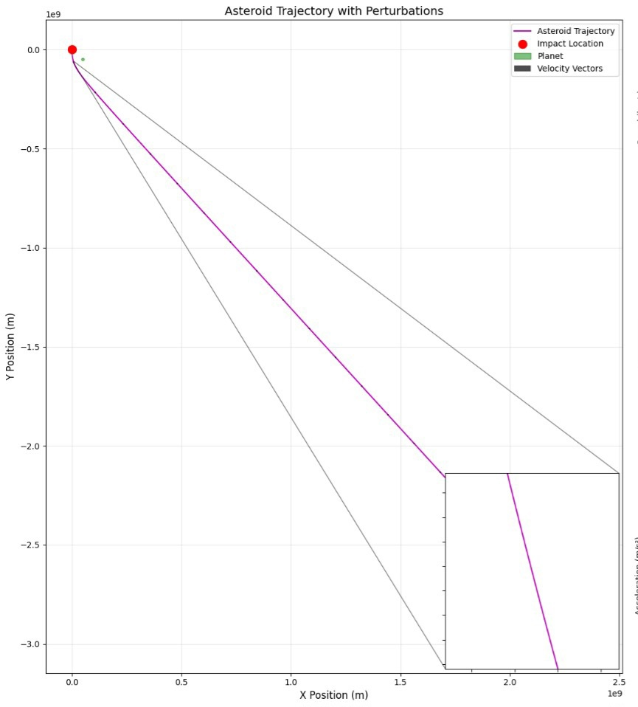

Main Trajectory Plot

A small zoomed-in subplot shows when the asteroid comes closest to the planet.

Speed vs. Time

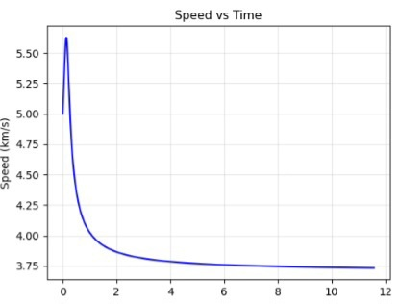

Graph showing how the asteroid's speed changes over time.

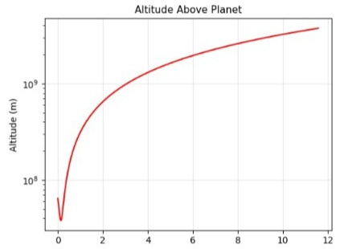

Altitude vs. Time

Logarithmic plot showing the asteroid's altitude above the planet.

Shows how the asteroid's total acceleration changes.

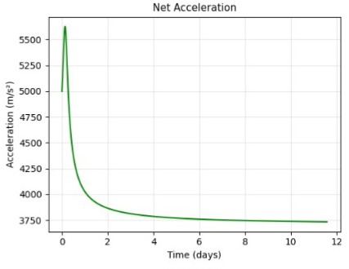

Acceleration vs time.

Phase 3

Sun Flares detection system

Predicting Solar Flare Peak Current and Energy Magnitude Using Recurrent Neural Networks

This project focuses on developing an advanced predictive model for forecasting solar flare characteristics, specifically peak current per second (c/s) and energy magnitude. Given the significant impact of solar flares on space weather, reliable forecasting is crucial for mitigating potential disruptions to satellite communications, power grids, and other technological infrastructures.

To achieve high predictive accuracy, the project leverages a variety of recurrent neural network (RNN) architectures, including:

Long Short-Term Memory (LSTM) – Well-suited for capturing long-term dependencies in time-series data.

Gated Recurrent Unit (GRU) – A computationally efficient alternative to LSTM with comparable performance.

Bidirectional LSTM + GRU – A hybrid approach that enhances feature extraction by processing data in both forward and backward directions.

Systematic Hyperparameter Tuning

To optimize model performance, systematic hyperparameter tuning is employed. Various optimization techniques are considered, such as:

Grid Search – Exhaustive search over predefined hyperparameter values.

Random Search – Randomly selecting hyperparameters within a given range to explore diverse configurations.

Bayesian Optimization – A probabilistic approach that efficiently searches for optimal hyperparameters based on prior evaluations.

Modular and Transparent Implementation

The project is designed with a modular architecture, ensuring flexibility and ease of experimentation. Each component—data preprocessing, model training, evaluation, and visualization—is structured to allow seamless modification and adaptation. Additionally, transparency is a key focus, enabling researchers and practitioners in the space weather community to reproduce and extend the work.

Significance and Applications

By providing an accurate and reliable tool for forecasting solar flares, this project contributes to space weather prediction research. The insights gained can assist in proactive measures for safeguarding critical technologies and infrastructure against the adverse

effects of solar activity.

Plots/ results.

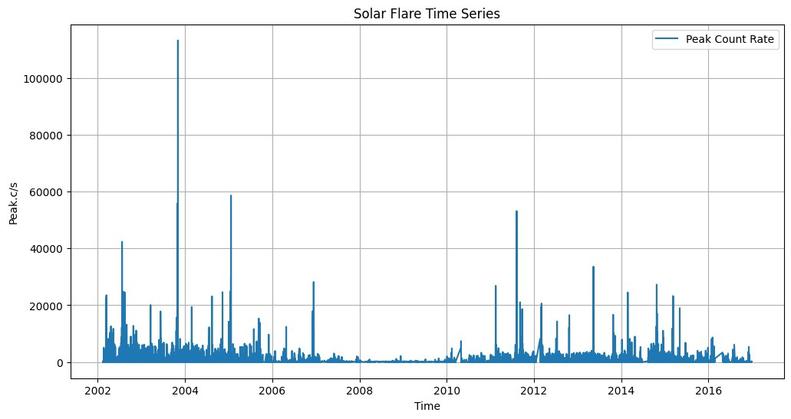

plot 1 time vs peak1

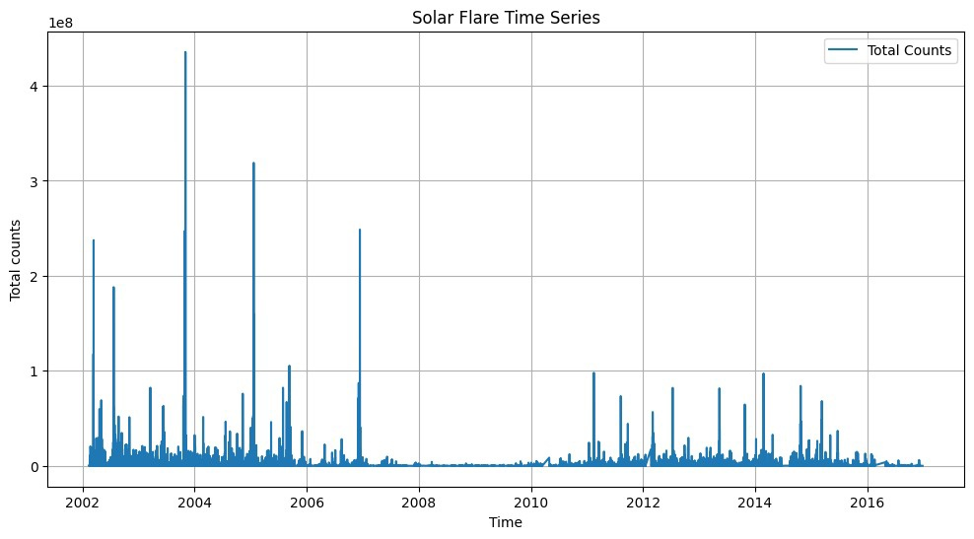

Plot 2 time vs total count.

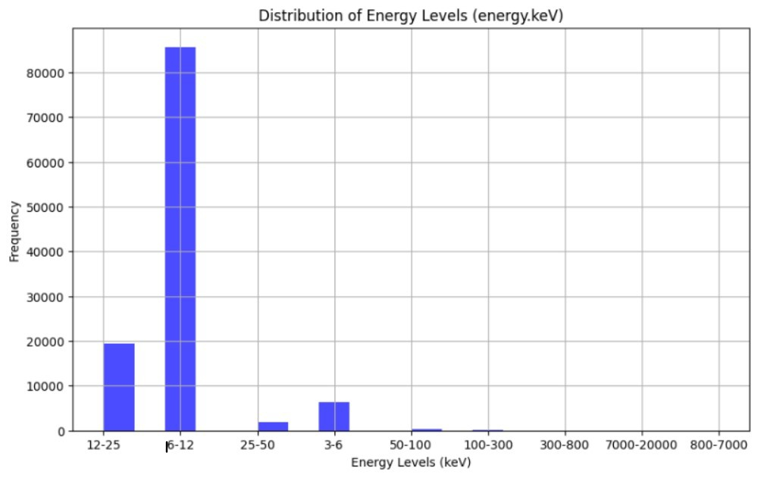

plot 3 energy levels vs frequency

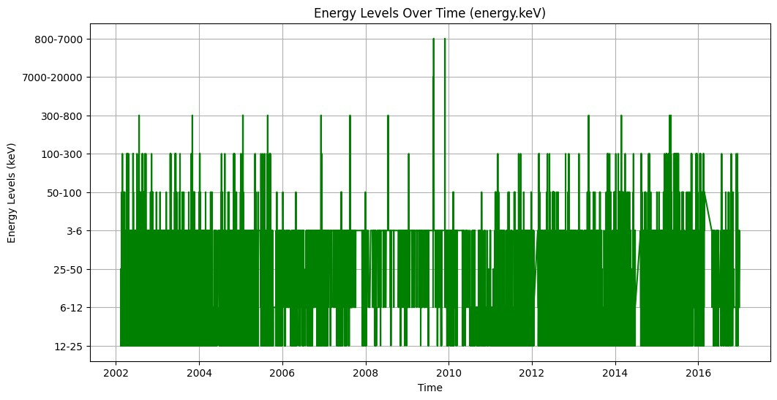

Plot 4 time vs EL

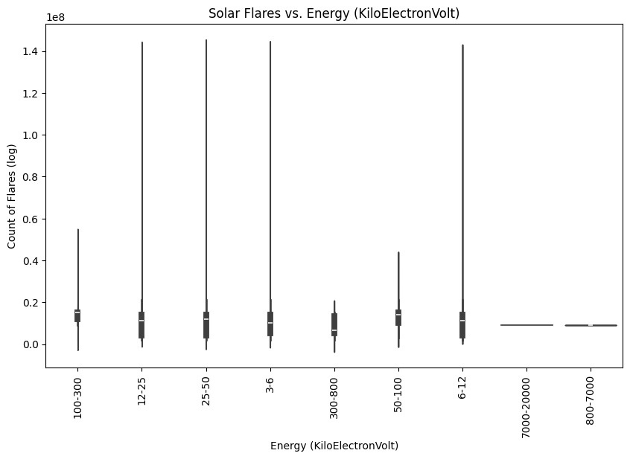

Plot 5 count vs energy.

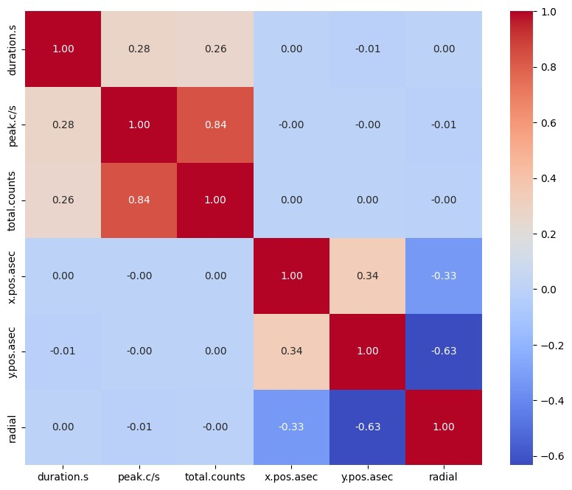

Chat 1.1 total

Phase 4

Ionospheric Shield System for Solar Storm Mitigation

1. Introduction

The increasing dependence on satellites, global communication networks, and power grids makes space weather a crucial area of study. Solar flares and geomagnetic storms can severely impact these systems, causing disruptions in satellite navigation, power failures, and even damage to spacecraft. This program simulates the effectiveness of an Ionospheric Shield System, leveraging ground-based high-frequency heaters (such as HAARP, EISCAT, and SURA) to mitigate the effects of solar storms by heating and modifying the ionosphere.

2. Key Components of the Program

This program integrates multiple disciplines, including space weather simulation, plasma physics, and ionospheric heating, to assess how effective artificially induced plasma turbulence can be in mitigating solar flare impacts.

2.1. Space Weather Simulation

A synthetic solar flare generator creates realistic space weather events by randomly selecting a flare class (C, M, or X-class flares) based on historical probabilities. The model generates key properties of the flare, such as:

Energy (keV) Duration (minutes) Particle density increase (m⁻³) Magnetic field variation (Tesla) This randomness allows for testing different intensities and conditions under which ionospheric mitigation strategies must function.

2.2. Plasma Heating Mechanic

The program includes a plasma physics model that simulates how the ionosphere reacts when exposed to high-frequency heating from ionospheric heaters. The model solves coupled differential equations that represent:

Nonlinear plasma heating : How injected electromagnetic energy raises ionospheric temperature. Recombination effects : The reduction in free electrons due to plasma cooling and natural decay processes.

By integrating these equations over time, we can estimate how much the ionosphere changes in response to the heaters.

2.3. Ionospheric Heater Network

Three well-known high-frequency heater facilities—HAARP (USA), EISCAT (Norway), and SURA (Russia)—are included in the model.

Each facility has different:

Power output (MW) Operating frequency (MHz) Geographic location (latitude & longitude) These parameters influence their ability to affect ionospheric plasma. The simulation measures their combined effectiveness in mitigating storm effects.

Result/ plots

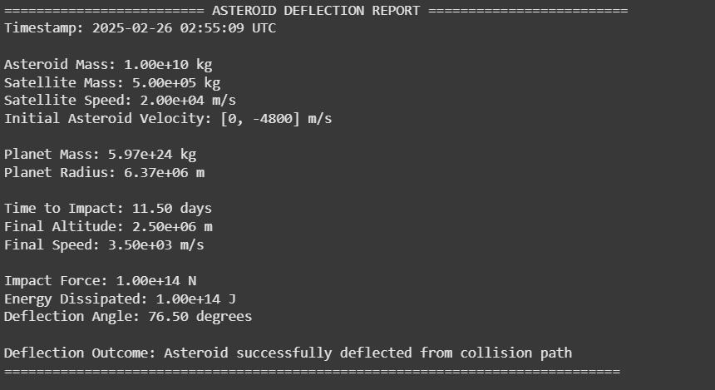

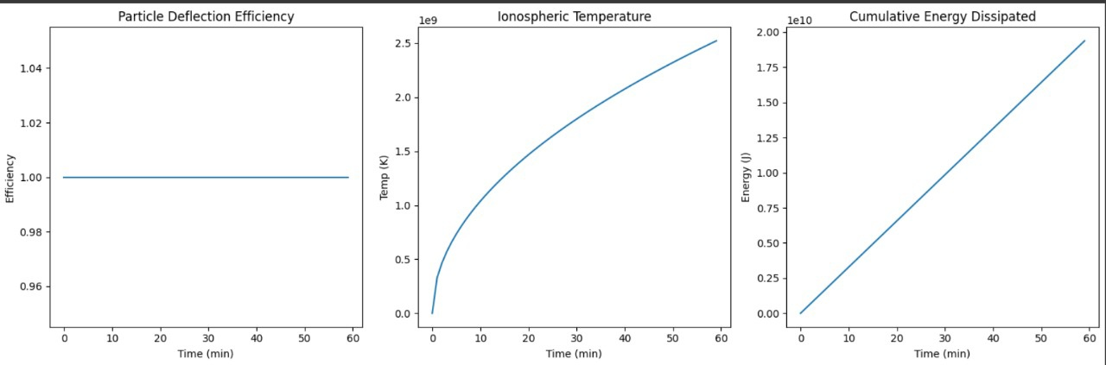

Plot 1 time vs particular Deflection vs isotopes temperature vs cumulative energy

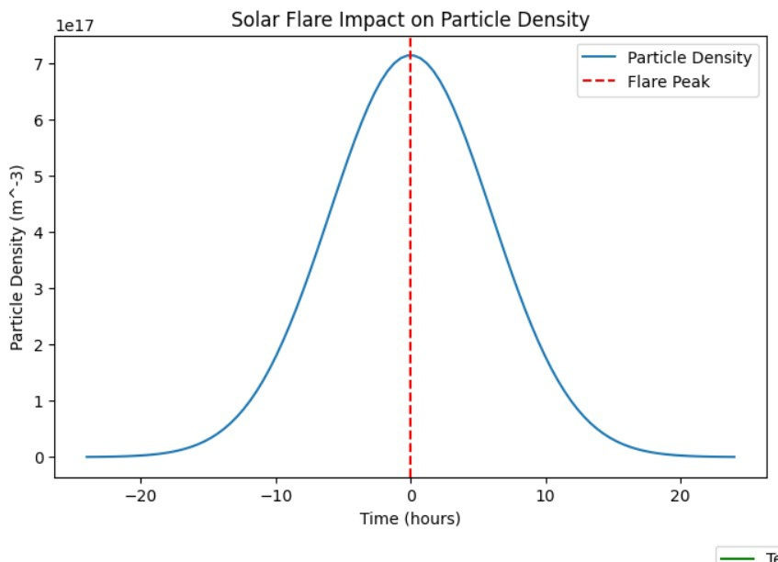

Plot 2 lmpact plot

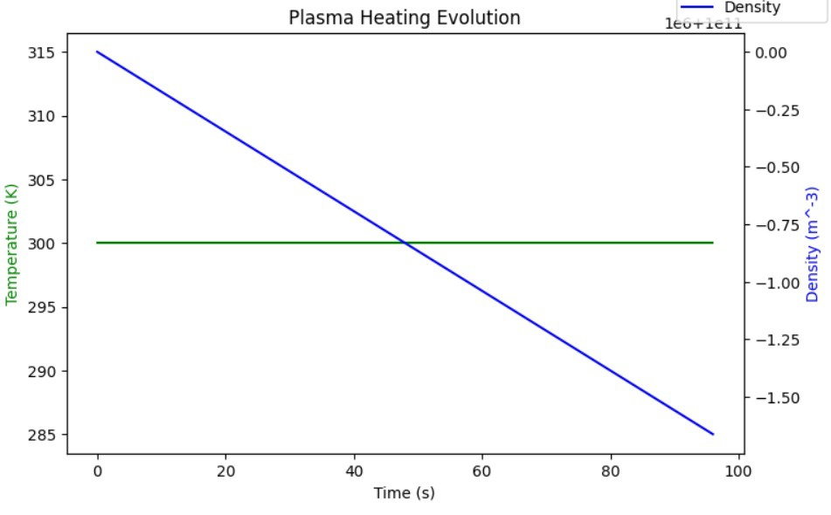

Plot 3 plasma heat evolution.

Technologies Used

- Python, NumPy, Pandas, TensorFlow, Scikit-learn

- LSTM, CNN, Attention Mechanism

- Time-Series Data Analysis & Feature Engineering

Goal

The primary objective of this project is to develop a highly accurate AI-based solar flare prediction model to aid space weather forecasting and satellite protection.

Contributions

Contributions are welcome! Feel free to fork, improve, or extend this project.

Conclusion

The analysis provides insights into asteroid characteristics, including size, velocity, distance, and brightness. These insights can be used in predictive modeling to identify potentially hazardous asteroids or classify asteroids based on their features.

This simulation models real-world asteroid behavior under external forces.

The visualization helps understand how an impact event affects an asteroid’s orbit.

It could be extended for space missions, deflection strategies, or collision predictions.